Software How-To
Using the Helpdesk Ticket System
You can use the Helpdesk to request help from the technology department of your local district. This will allow you to receive email’s regarding updates and any changes in the request. You can also look at historical information about your requests. To use the Helpdesk System, do the following:

Logging In
- Open your favorite browser and go to: http://support.swmitech.org
- Log in using your windows account user name and password. This is your Active Directory account credentials, the same you would use to login to the computer, or your email.
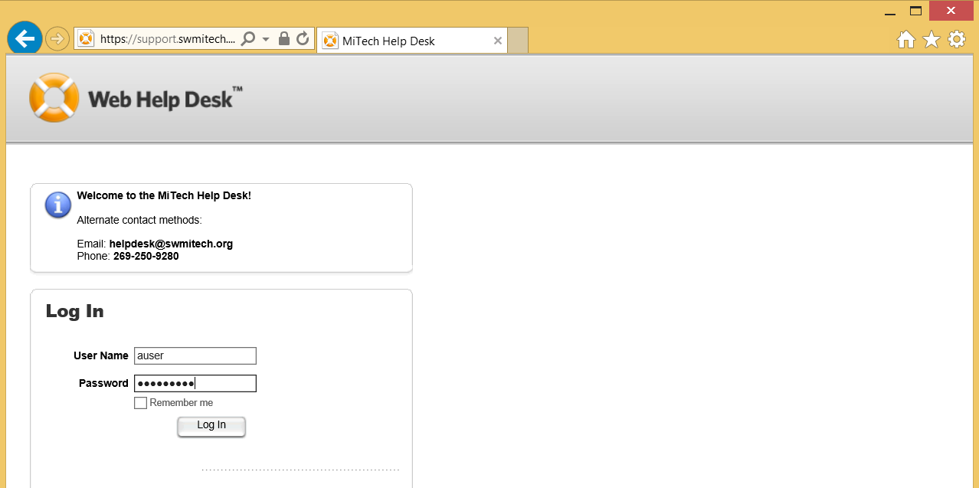

- If you do not have an email address associated with your account, you will be prompted to enter one. Please enter your staff email account here. 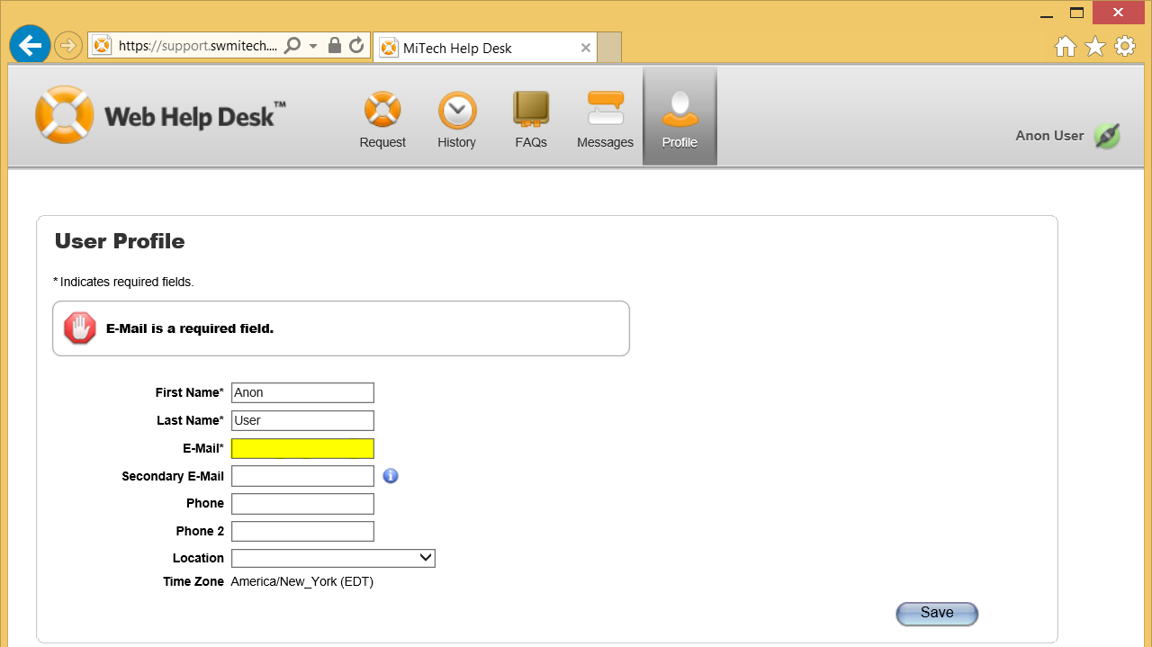

- Click the Save button once you’ve enter your email address.
- Next click the Request button at the top of the page to start entering a new ticket.

Submitting a Ticket
- Once you’re logged in, you will be taken to the new request screen automatically.
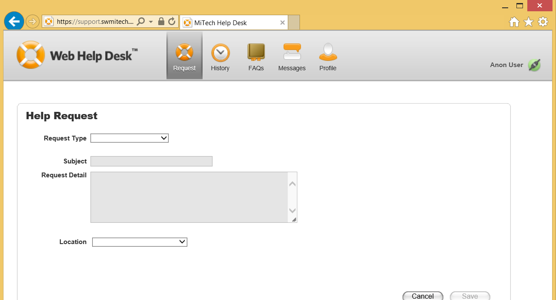

- Start the ticket by selecting your Request Type. These types are fairly generic but get more specific in subsequent selections.
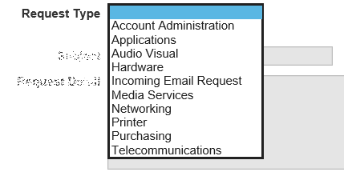
Select the types that best reflect the type of issue you are having.
- Continue to fill in the remaining fields.
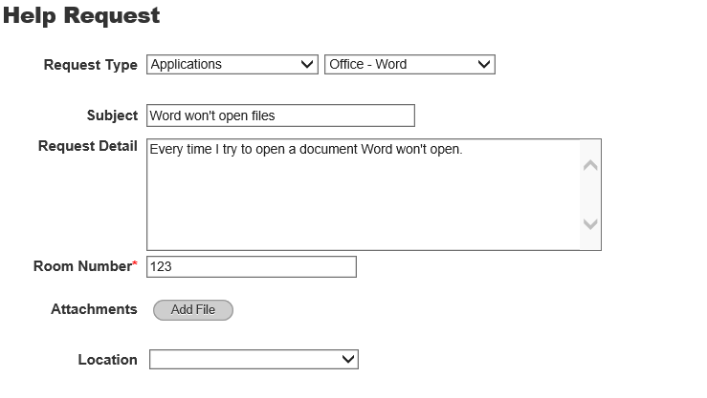
- The Location field will be specific to you and should contain your site specific locations.
- Once you’ve filled in all of the fields, click the Save button to continue.
Once your ticket is saved it will send you a notification email. This will have a link back to the ticket within it.

Updating a Ticket
- Once you’re logged into the helpdesk, it will take you to the ticket entry screen. You are going to want to click on the History button at the top of the page:
- This will display a list of all of your submitted tickets.
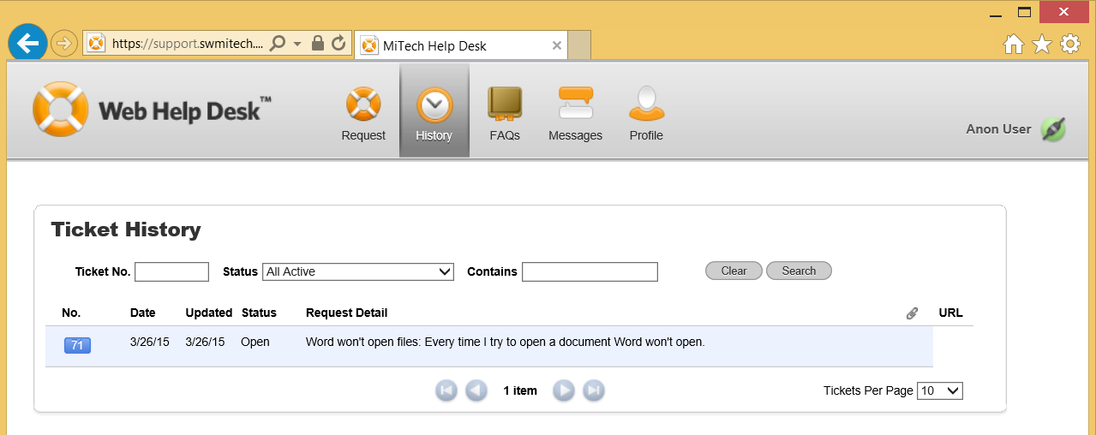

- To display the details of the ticket, click on the blue ticket number at the very left of the list.
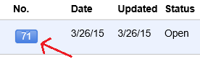
- Here you will be able to see the details of the ticket and any notes entered in the ticket. You’ll also be able to enter additional notes about it and communicate directly back to who the ticket is assigned to. 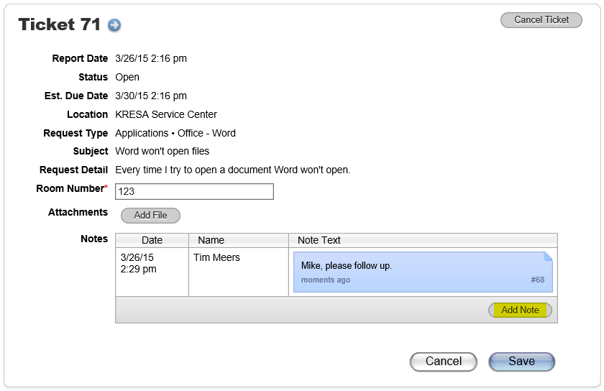

- Just click the Add Note button in the bottom corner and entering a new note. Once you’ve entered your note click Save and it will add it to the ticket
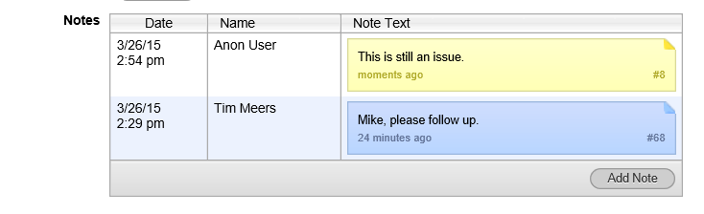
You will see your new note in yellow.

Status Definitions
Status | Comment | Effective Status
Open | Initial status of new ticket. Ticket may also be actively being worked. | Open
In-Progress | Ticket is being actively worked on. | Open
Pending - On Order | Ticket waiting for an order to be placed/shipped | Open
Pending - Waiting for Feedback | Ticket waiting for client/tech/other feedback before continuing | Open
Closed | Ticket is closed. | Closed
Resolved | A ticket that should be completed but needs final review from client. Will auto close in 3 days. | Pending Closure
Cancelled | Tickets cancelled by client, or not needed. | Closed
Reopened | Tickets reopened by client/tech and not assigned/updated further. | Open
First Level Resolution | Ticket resolved by helpdesk/tech without having to escalate or assign to another group | Closed

